Name | Order | Instructions/ dietary requirements
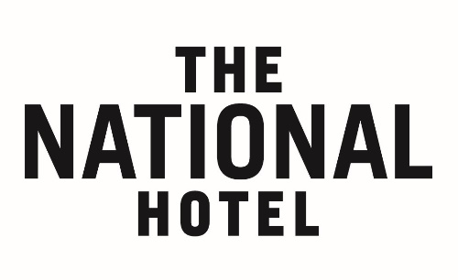
LUNCH PRE ORDER FORM
The National Hotel
191 Moorabool Street Geelong, 3220
ph: 5229 9407
email: info@nationalgeelong.com.au

If for some reason a person does not attend and the meal has been made it will still need to be paid for.
We do split bills – this can take some time when large numbers are paying all together so to save your time if people could pay at different times that will help alleviate the wait at the end.
Contact Details
Booking Name: _____________________________
Company Name:____________________________
Contact Number: ___________________________
Contact Email: _____________________________

Meals will be brought out 5-10 minutes after you’re
given arrival time. If for some reason you are running late
contact the hotel and we will hold the meals.

- Please return this form by 10:30am on the day of booking via email
- Lunch 11:30am – 2:30pm
- Please also let us know of any late arrivals and confirmation of total attendees even if some are not pre ordering

